Session 13 - Recursion + Scope: Task Report

Task 1: Print Playlist Songs
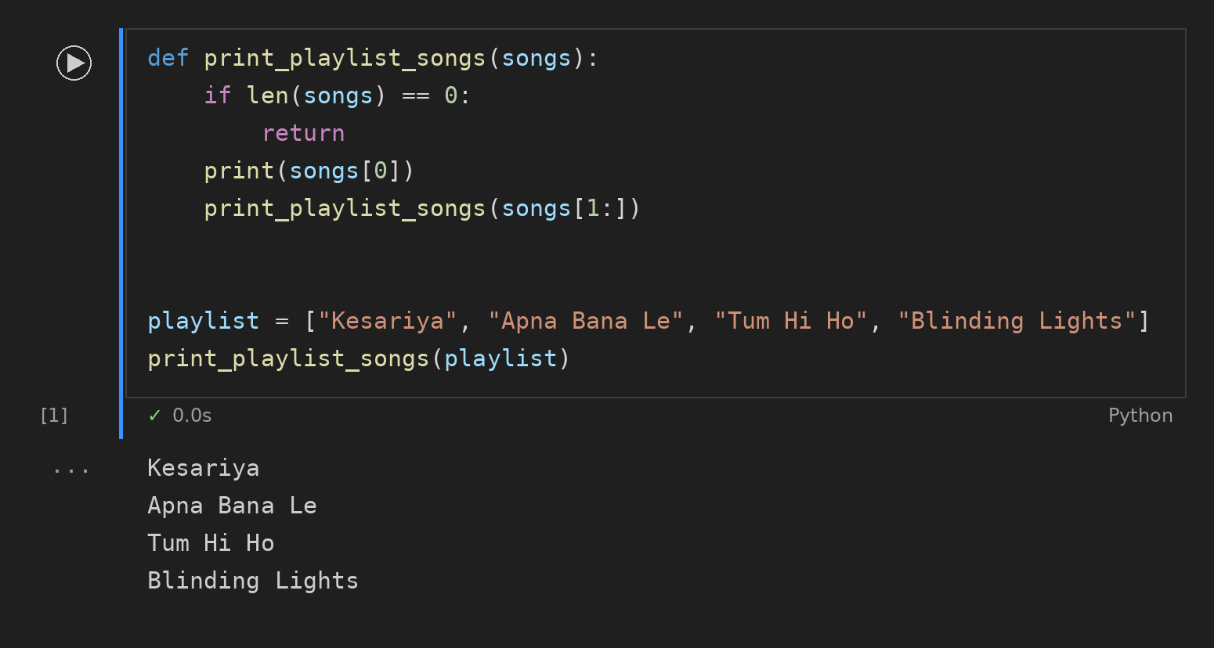

Task 2: Count Unread Messages
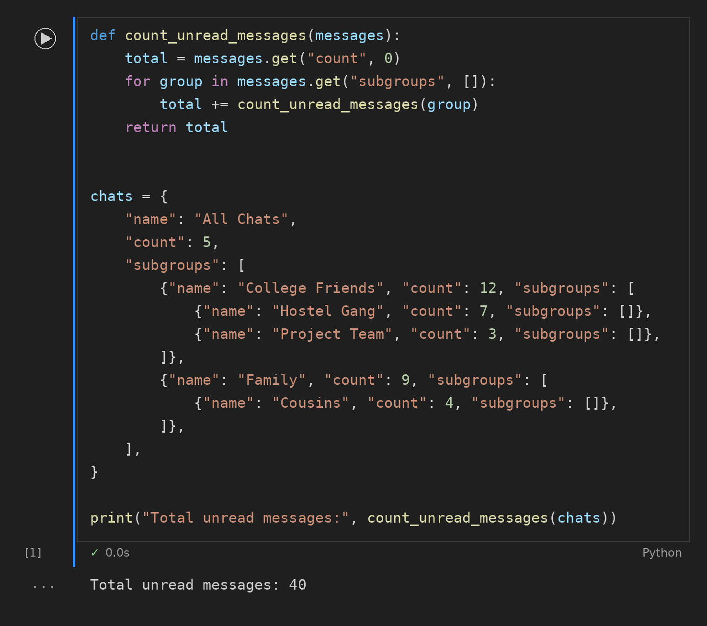

Task 3: Local and Global Scope
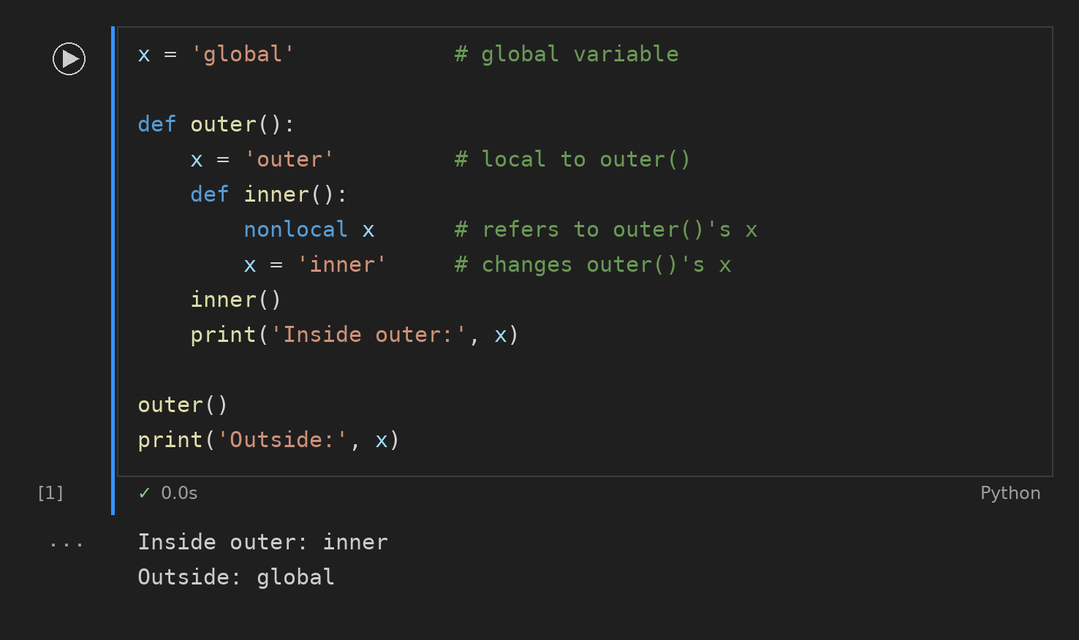

Task 4: Format Number Short
